OBJECT ORIENTED PROGRAMMING

Lab 3: Basic Java syntax

### Exercise 1:

Knowing the following declarations

**byte b1 = 10, b2 = 20 ;**

**short p = 200 ;**

**int n = 500 ;**

**long q = 100 ;**

**float x = 2.5f ;**

**double y = 5.25 ;**

**char c = 60, ce = 'e', cg = 'g' ;**

**byte b = 10 ;**

Give the type and the value of the following arithmetic expressions

**b1+b2 // 1 int 30**

**p+b1 // 2 int 210**

**b1*b2 // 3 int 200**

**q+p*(b1+b2); // 4 long 6100**

**x+q*n // 5 float 50002.5**

**b1*q/x // 6 float 400.0**

**b1*q*2./x // 7 double 800.0**

**b1*q*2.f/x // 8 float 800.0**

**c + 1 // 9 61 int**

**2 * c // 10 120 int**

**cg – ce // 11 2 int**

**b * c // 12 600 int**

### Exercise 2:

What results does this program provide?

**public class CourCir**

**{**

**public static void main (String args[]){**

**int i=10, j=5 ;**

**if (i<5 && j++<10) System.out.println ("&&1 vrai") ;**

**else System.out.println ("&&1 faux") ;**

**System.out.println ("i = " + i + " j = " + j) ;**

**if (i<5 & j++<10) System.out.println ("& vrai") ;**

**else System.out.println ("& faux") ;**

**System.out.println ("i = " + i + " j = " + j) ;**

**if (i<15 && j++<10) System.out.println ("&&2 vrai") ;**

**else System.out.println ("&&2 faux") ;**

**System.out.println ("i = " + i + " j = " + j) ;**

**if (i<15 || j++<10) System.out.println ("|| vrai") ;**

**else System.out.println ("|| faux") ;**

**System.out.println ("i = " + i + " j = " + j) ;**

**}**

**}**

&&1 faux

i = 10 j = 5

& faux

i = 10 j = 6

&&2 vrai

i = 10 j = 7

|| vrai

i = 10 j = 7

### Exercise 3:

What results does this program provide?

**public class OpCond**

**{**

**public static void main(String[] args){**

**int n=10, p=5, q=10 ;**

**n = p = q = 5 ;**

**n += p += q ;**

**System.out.println ("A : n = " + n + " p = " + p + " q = " +q) ;**

**q = n < p ? n++ : p++ ;**

**System.out.println ("B : n = " + n + " p = " + p + " q = " +q) ;**

**q = n > p ? n++ : p++ ;**

**System.out.println ("C : n = " + n + " p = " + p + " q = " +q) ;**

**}**

**}**

A : n = 15 p = 10 q = 5

B : n = 15 p = 11 q = 10

C : n = 16 p = 11 q = 15

### Exercise 4:

Write a program that calculates the square roots of numbers given in data. It will stop when given a value of 0[1]. It will refuse negative values. Its execution will look like this:

**donnez un nombre positif : 2**

**sa racine carree est : 1.4142135623730951**

**donnez un nombre positif : -3**

**svp positif**

**donnez un nombre positif : 5**

**sa racine carree est : 2.23606797749979**

**donnez un nombre positif : 0**

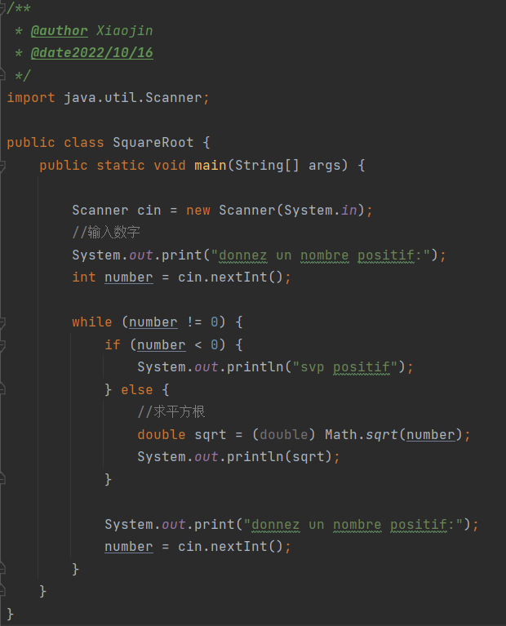

### Exercise 5:

Write a program calculating the sum of the first n terms of the "harmonic series", i.e. the sum:

**1 + 1/2 + 1/3 + 1/4 + ..... + 1 / n**

The value of n will be read as data[2].

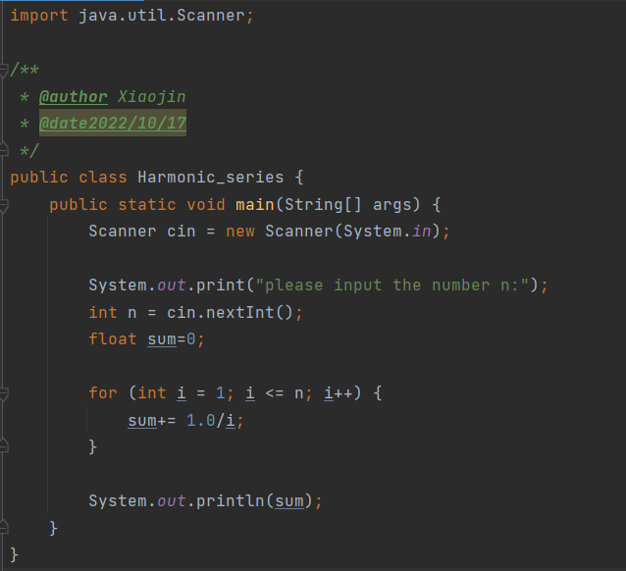

### Exercise 6:

Write a program that displays an isosceles triangle made up of stars. The height of the triangle (i.e. its number of lines) will be given as data, as in the example below. We will arrange for the last line of the triangle to appear on the left edge of the screen.

**combien de lignes ? 8**

**\***

**\*\*\***

**\*\*\*\*\***

**\*\*\*\*\*\*\***

**\*\*\*\*\*\*\*\*\***

**\*\*\*\*\*\*\*\*\*\*\***

**\*\*\*\*\*\*\*\*\*\*\*\*\***

**\*\*\*\*\*\*\*\*\*\*\*\*\*\*\***

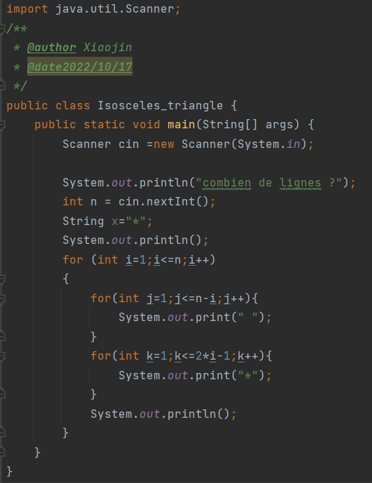

1. Recall that the Math.sqrt method provides a result of type double corresponding to the value of type double supplied as an argument.
2. We can use the class Clavier found in the src folder.